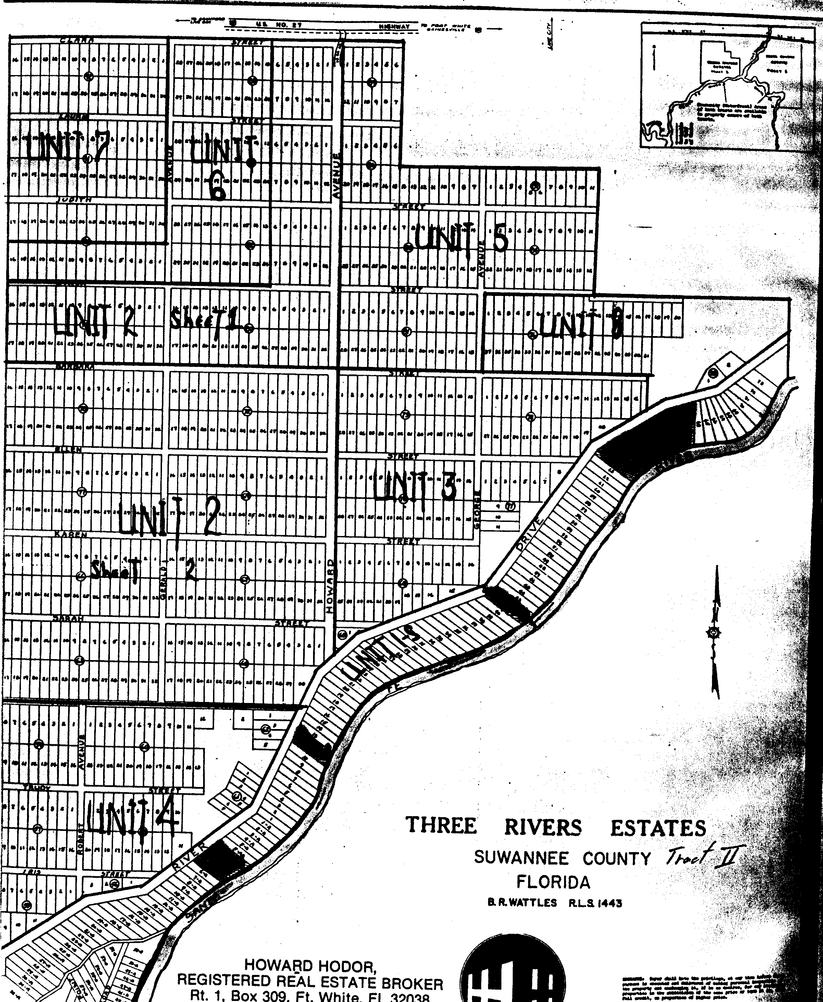
Suwannee County Plot Map – Old information found – might help you locate some of our parks. Some of the Street names have changed.

